CMPE-272 Enterprise Software Platform

Homework:07 Security

Team Name: Techie-Tribe

Members - Bhavya Tetali, Pranjali Kotgire, Priti Sharma, Supriya Meduri

**Git Repo**: https://github.com/supriyameduri9/CMPE272-Security-TechieTribe/tree/master

**Assignment:**  **Design and build a PKI infrastructure that includes Root CA, Signing CA, and TLS Certificate and use TLS certificate to install a web server.**

Steps:

1. To begin, fetch this Simple PKI example files and change into the another directory

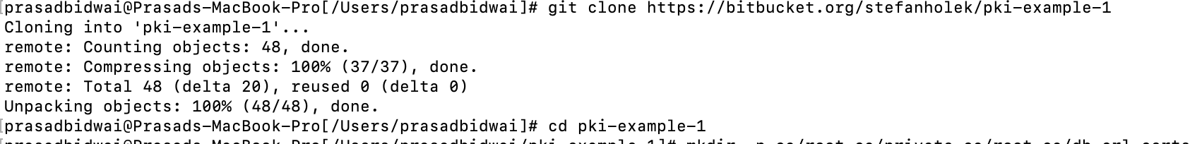

1. Create Root CA

2.1 create Directories:

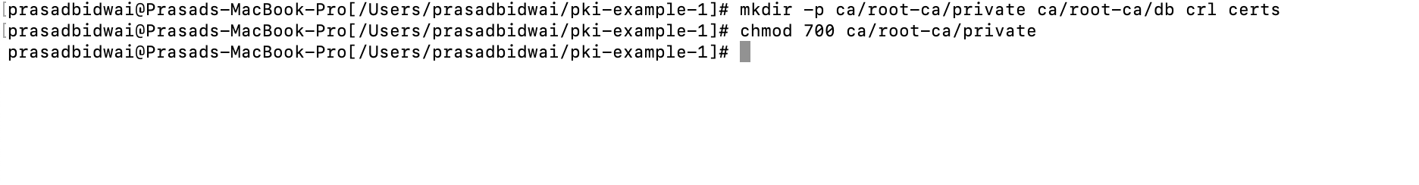

2.2 Create Database:



2.3 Create CA request:

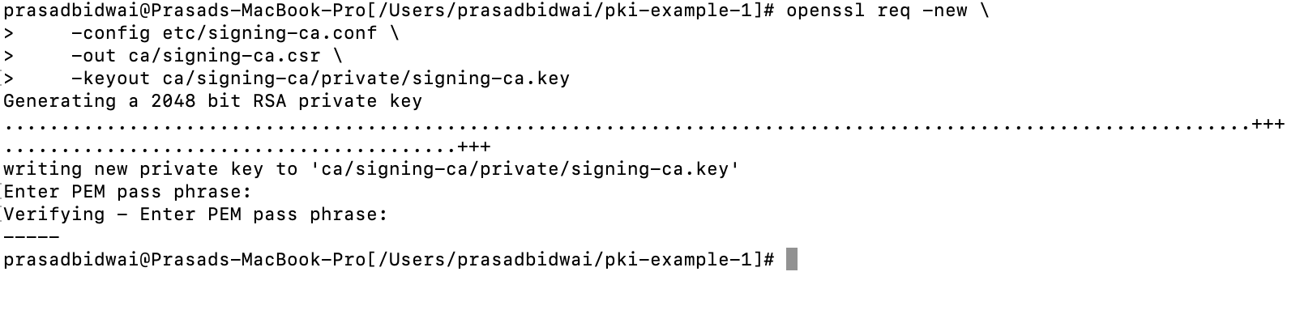

2.4 Create CA certificate:

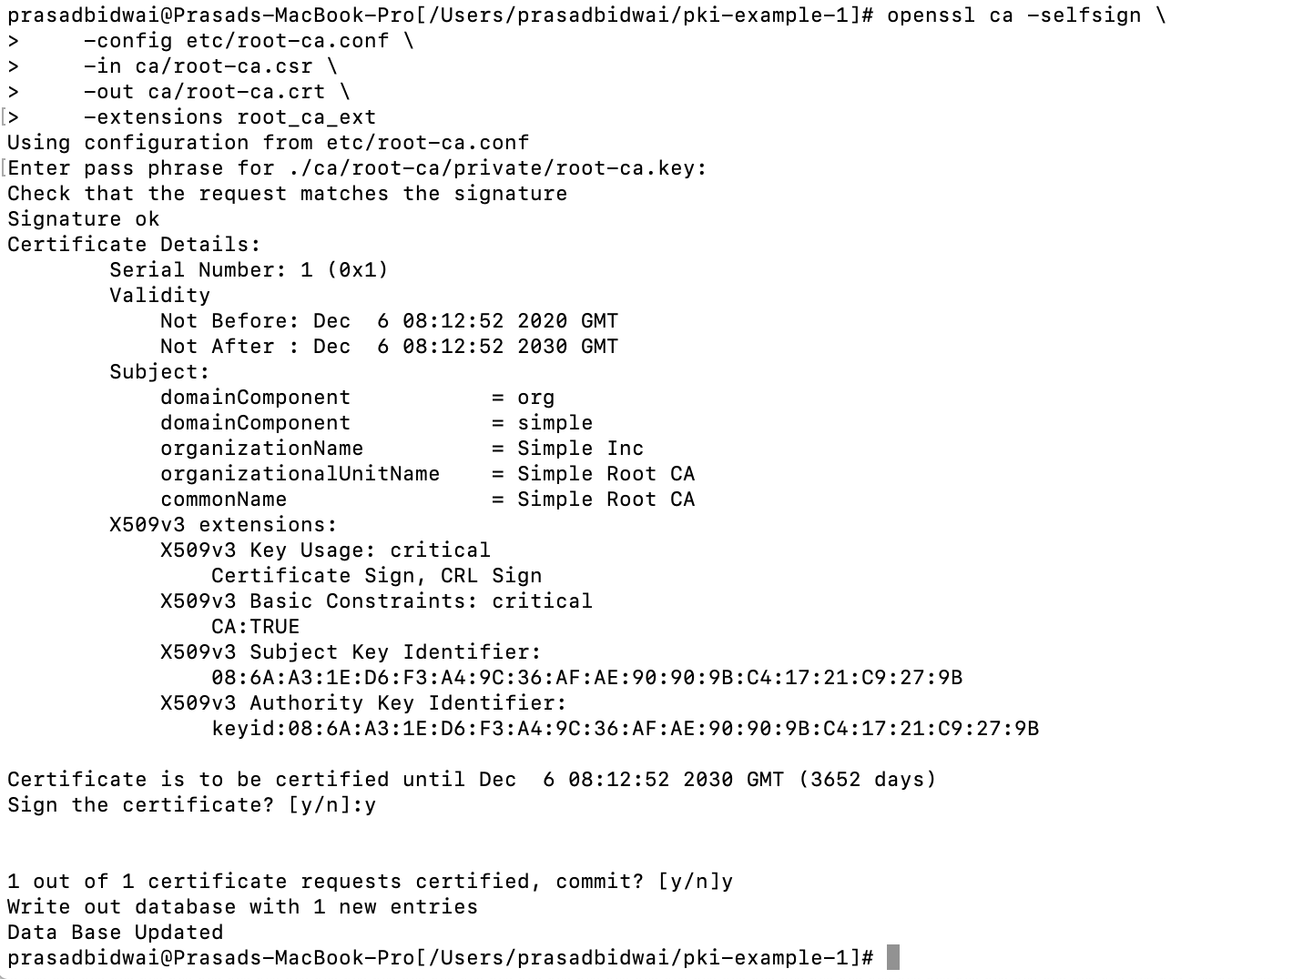

1. Create Signing CA:

3.1 Create Directories:



3.2 Create Database:



3.3 Create CA request:

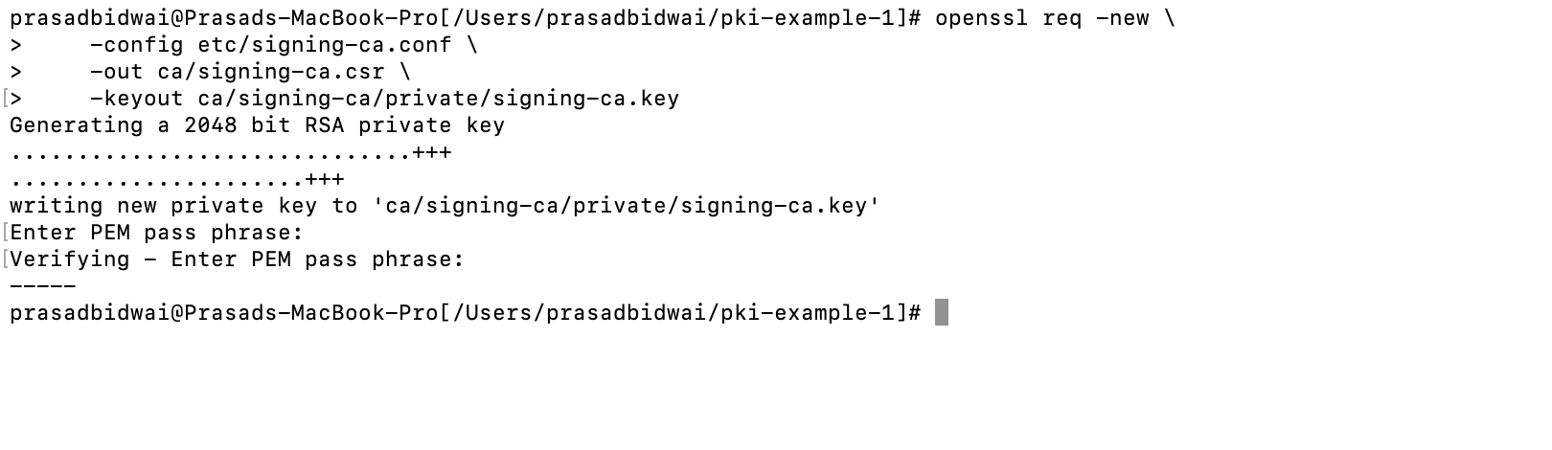

3.4 Create CA certificate:

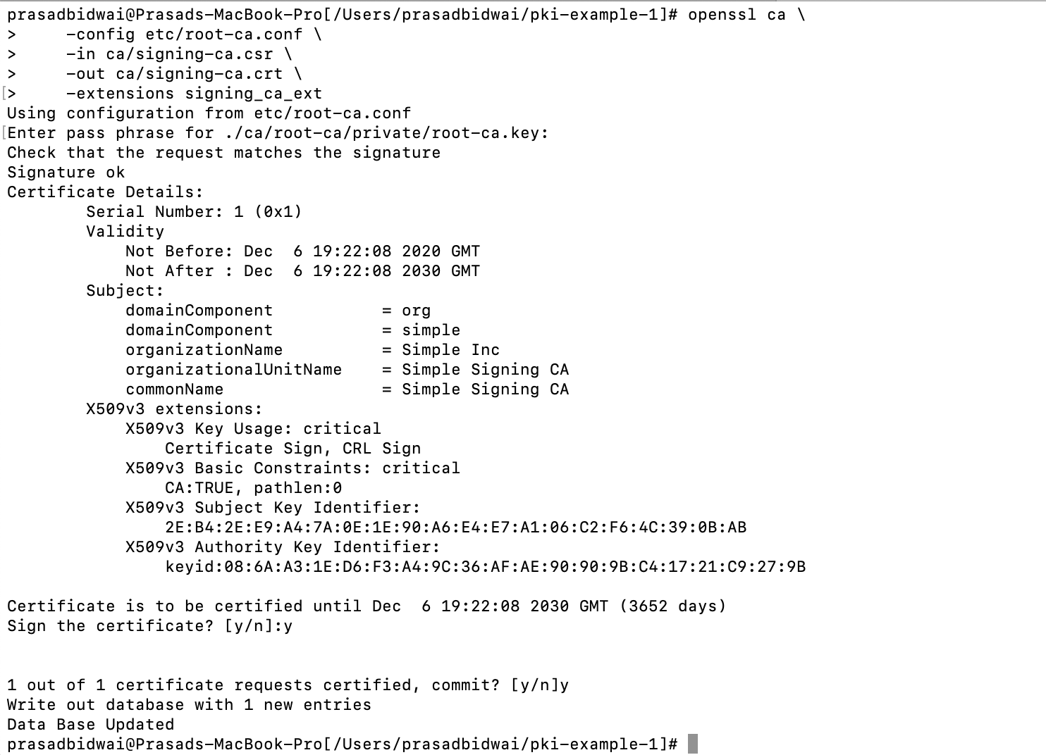

1. Operate Signing CA

4.1 Create TLS server request:

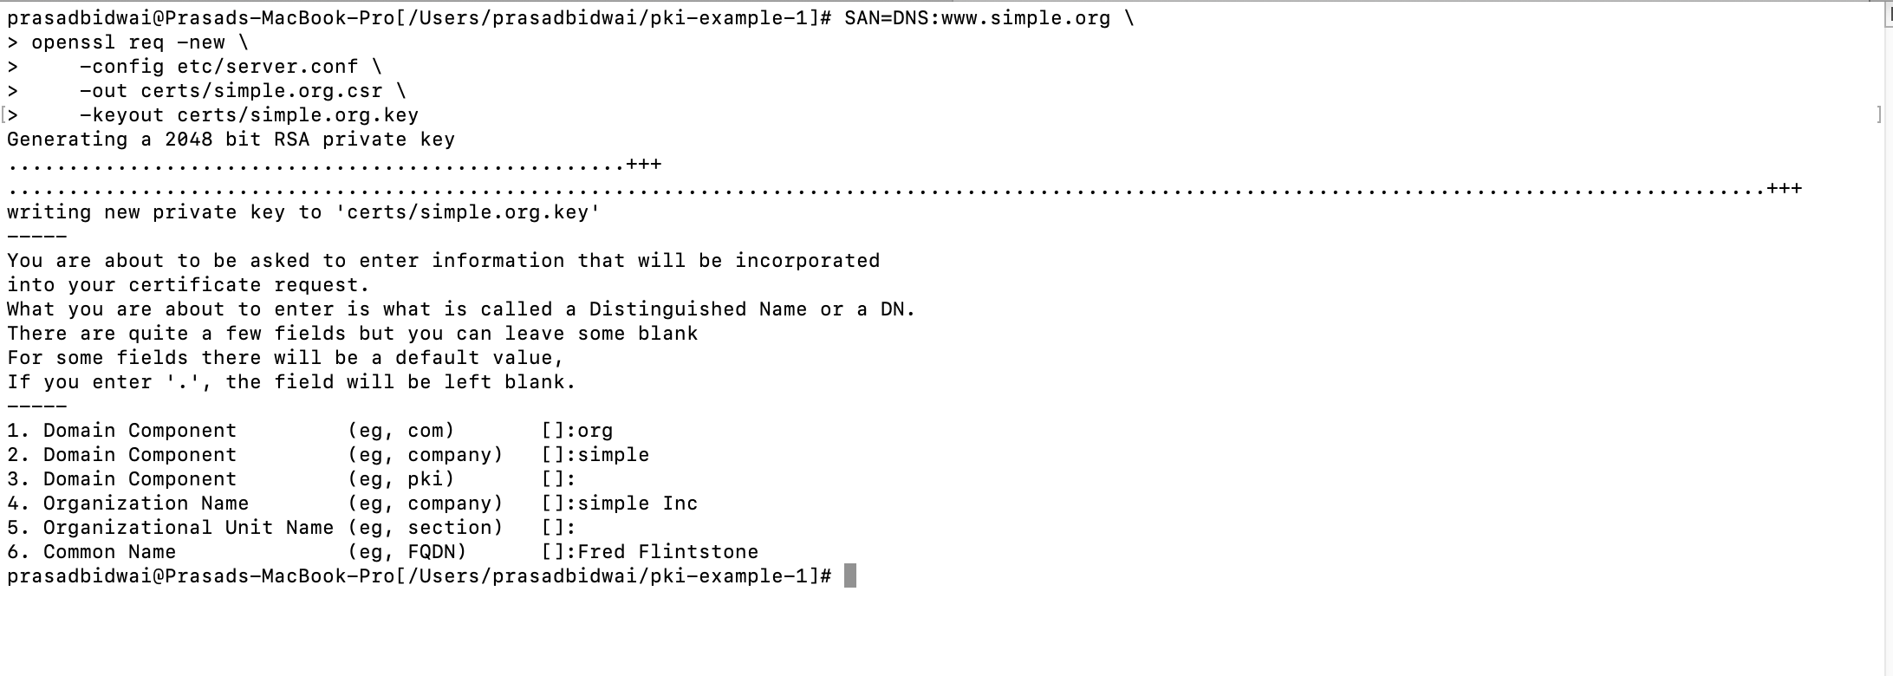

4.2 Create TLS server certificate:

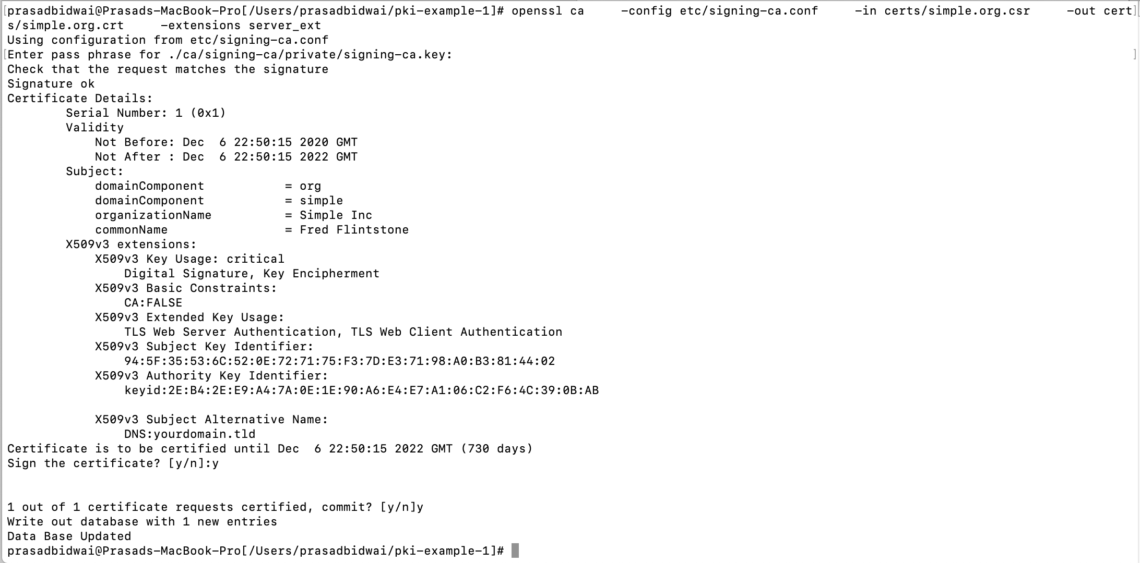

Section 2:

1. Download and install Tomcat:
2. Download and install java:

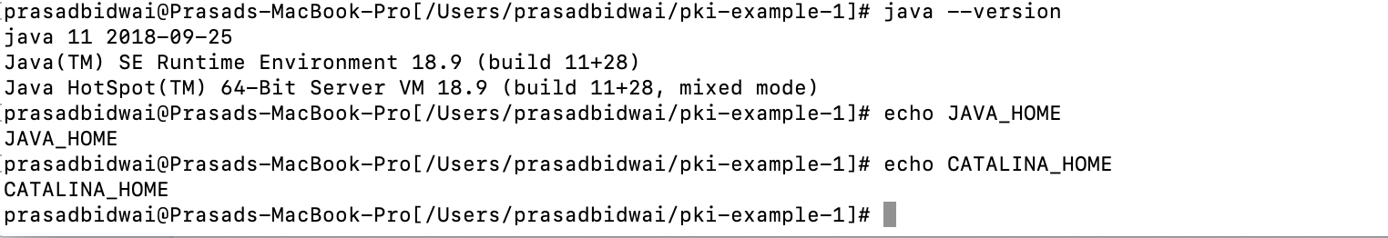

1. Prepare certificate keystore and import the certificate

1] Creating a keystore file:



2] Importing existing certificate to PKCS 12 keystore using OpenSSL:

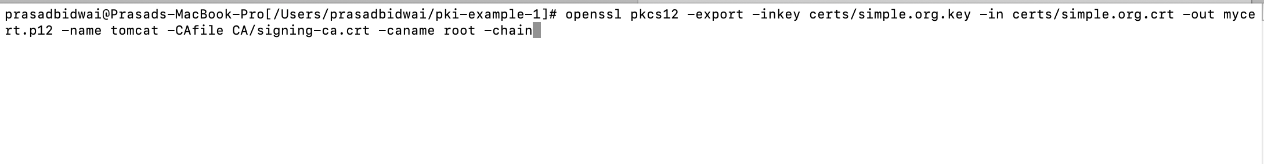

3] Import the chain Certificate:

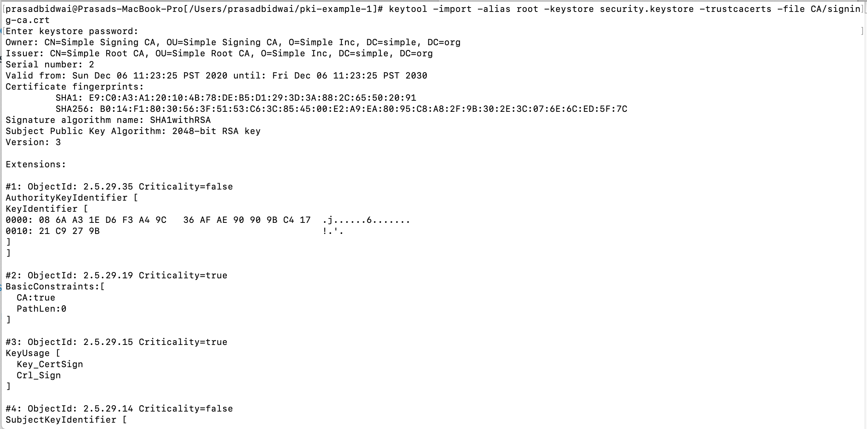

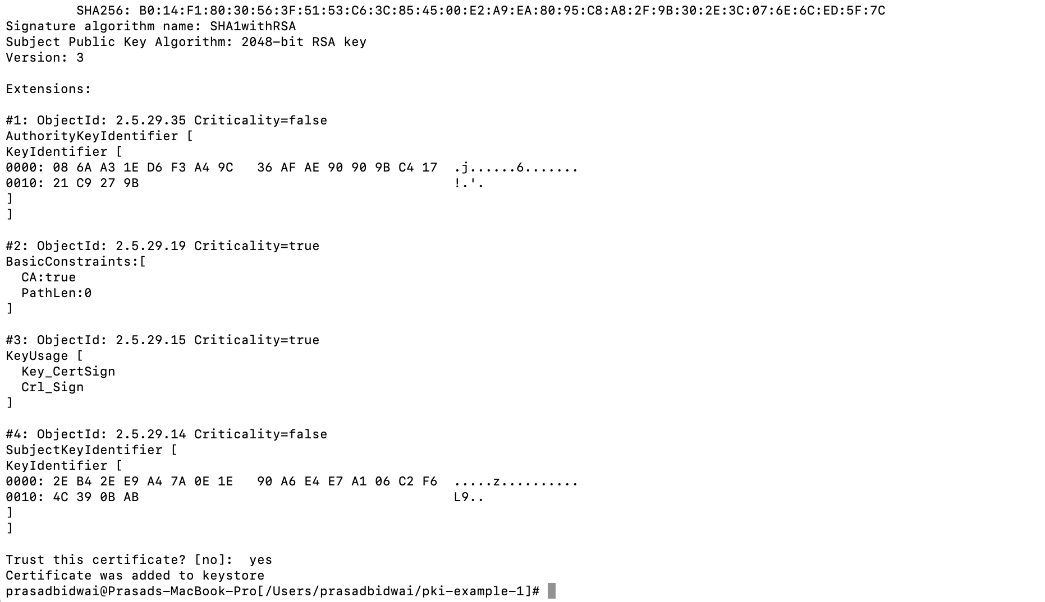

4] Now edit the configuration file of tomcat: (/Users/prasadbidwai/tomcat/bin/server.yml)

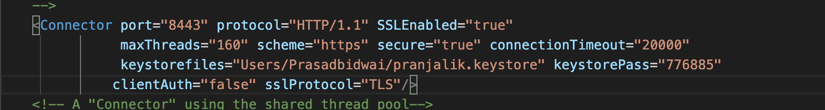

5] Start Tomcat: (/Users/prasadbidwai/tomcat/bin/startup.sh)

